DATA ANALYSIS AND VISUALISATION
PROJECT REPORT
(Project Semester January-April 2025)

CHICAGO CRIME ANALYTICS DASHBOARD

Submitted by

Krishika Malhotra

Registration No: 1241394

Programme and Section : 4M209
Course Code : INT 387

Under the Guidance of

Dr. Baljinder Kaur

Discipline of CSE/IT

Lovely School of Computer Science

Lovely Professional University, Phagwara

CERTIFICATE

This is to certify that Krishika Malhotra bearing Registration no. 12413944 has completed INT 387 project titled, “Chicago Crime Analytics Dashboard” under my guidance and supervision. To the best of my knowledge, the present work is the result of his/her original development, effort and study.

Signature and Name of the Supervisor
Designation of the Supervisor
School of Computer Science
Lovely Professional University
Phagwara, Punjab.

Date: April 19, 2026

DECLARATION

I, Krishika Malhotra, student of Bachelor of Technology under CSE/IT Discipline at, Lovely Professional University, Punjab, hereby declare that all the information furnished in this project report is based on my own intensive work and is genuine.

Date: April 19,2026
Registration No.: 12413944
Name: Krishika Malhotra

ACKNOWLEDGEMENT

I would like to express my sincere gratitude to my esteemed faculty mentor for their continuous guidance, encouragement, and valuable suggestions throughout the course of this project. Their insightful feedback and support played a crucial role in shaping this work and helping me achieve a deeper understanding of data analysis and visualization.
I am also thankful to Lovely Professional University for providing a conducive learning environment, necessary resources, and the opportunity to work on such a practical and insightful project. The exposure to tools like Power BI and real-world datasets has significantly enhanced my analytical and technical skills.
I would like to extend my appreciation to all the online platforms and documentation resources, including Spotify’s developer documentation and Power BI learning materials, which served as an essential source of knowledge during the completion of this project.
Lastly, I am grateful to my peers and friends for their constant support, motivation, and constructive discussions, which contributed positively to the successful completion of this project.

TABLE OF CONTENTS
      - Introduction
      - Source of Dataset
      - Dataset Preprocessing
      - Analysis on Dataset
      - Conclusion
      - Future Scope
      - References

LinkedIn Post: https://www.linkedin.com/posts/krishika-malhotra-b11297333_powerbi-dataanalytics-datavisualization-ugcPost-7452231817425780736-acJI?utm_source=share&utm_medium=member_desktop&rcm=ACoAAFPeln0B69BBh-KBEmF9L9Ym6uqQ8nShqEU

Project Link: https://drive.google.com/drive/folders/1qIbRu_qKyAeooDiF3Qe6HVSWth-1tkTI?usp=drive_link

Dataset Link: https://data.cityofchicago.org/Public-Safety/Crimes-2001-to-Present/ijzp-q8t2/data_preview

INTRODUCTION

Crime analysis plays a crucial role in understanding patterns of criminal activity and enabling data-driven decision-making for law enforcement and public safety agencies. With the rapid growth of urban populations and increasing complexity of crime dynamics, traditional methods of analysis are no longer sufficient. This has led to the integration of data analytics and artificial intelligence techniques to uncover hidden trends, predict potential risks, and support proactive policing strategies.
The city of Chicago has long been a focal point for crime data analysis due to the availability of detailed and publicly accessible datasets. These datasets include information such as crime type, location, time of occurrence, and arrest status, making them highly suitable for analytical and predictive modeling. By leveraging such data, it becomes possible to identify high-risk areas, analyze temporal trends, and understand the distribution of different types of crimes across the city.
This project focuses on analyzing crime data from Chicago using data science techniques to extract meaningful insights and patterns. The primary objective is to explore crime trends, identify key factors influencing criminal activity, and visualize patterns that can aid in better understanding urban crime behavior. Additionally, the project aims to demonstrate how data analytics can be used as a powerful tool in addressing real-world societal challenges.
By applying statistical analysis and visualization techniques, this study provides a structured approach to crime analysis. The findings of this project can contribute to improved awareness, better resource allocation, and informed decision-making, ultimately supporting efforts to enhance public safety and reduce crime rates.

OBJECTIVES

The primary objective of this project is to analyze crime data from Chicago in order to identify patterns, trends, and key factors influencing criminal activities. The study aims to utilize data analytics techniques to transform raw crime data into meaningful insights that can support better understanding and decision-making.
The specific objectives of the project are as follows:

- To explore and understand the structure and characteristics of the Chicago crime dataset.
- To perform data preprocessing, including handling missing values and cleaning inconsistencies.
- To analyze crime trends over time to identify patterns in frequency and distribution.
- To examine the geographical distribution of crimes across different areas of the city.
- To identify the most common types of crimes and their occurrence patterns.
- To visualize data using charts and graphs for better interpretation of results.
- To derive actionable insights that can contribute to improved awareness and public safety.

PROBLEM STATEMENT

Urban crime presents a significant challenge to public safety, law enforcement efficiency, and overall quality of life. In large metropolitan cities like Chicago, the volume and complexity of crime data make it difficult to manually identify patterns, trends, and high-risk areas. Traditional approaches to crime analysis often rely on static reports and limited statistical summaries, which are insufficient for understanding dynamic and evolving crime behavior.

The availability of large-scale crime datasets provides an opportunity to apply data analytics techniques for deeper insights. However, raw data alone does not directly translate into actionable information. There is a need for systematic analysis to uncover meaningful patterns related to crime type, location, time, and frequency.

The core problem addressed in this project is:
How can crime data from Chicago be effectively analyzed using data science techniques to identify patterns, trends, and insights that support better understanding of criminal activity and assist in decision-making?

This project aims to bridge the gap between raw data and actionable insights by applying data preprocessing, exploratory analysis, and visualization techniques. The goal is to transform complex datasets into clear, interpretable information that can highlight crime hotspots, temporal trends, and key influencing factors.

LITERATURE REVIEW

Crime analysis has been a widely studied area within data science, criminology, and urban planning. Researchers have increasingly adopted data-driven approaches to understand crime patterns and improve public safety strategies. The use of statistical methods, machine learning, and visualization tools has significantly enhanced the ability to analyze large-scale crime datasets.

Several studies have focused on identifying spatial and temporal patterns in crime data. Geographic Information Systems (GIS) and heatmap visualizations have been widely used to detect crime hotspots and high-risk areas within cities. These methods help law enforcement agencies allocate resources more effectively and respond proactively to crime-prone regions.

Time-series analysis has also been applied to study crime trends over different periods, such as daily, monthly, or yearly patterns. This helps in understanding seasonal variations and recurring trends in criminal activities. Additionally, classification and clustering techniques have been used to group similar types of crimes and identify underlying relationships between different variables.

With the advancement of machine learning, predictive models have been developed to forecast potential crime occurrences based on historical data. These models assist in anticipating future risks and enabling preventive measures. However, many existing approaches face challenges such as data quality issues, missing values, and lack of interpretability.

This project builds upon these existing methodologies by focusing on exploratory data analysis and visualization techniques to derive meaningful insights from crime data. Unlike purely predictive models, the emphasis here is on interpretability and clarity, ensuring that the results are easy to understand and practically useful.

DATASET DESCRIPTION

The dataset used in this project is the publicly available crime dataset from Chicago, which contains detailed records of reported criminal incidents. This dataset is widely used for analytical and research purposes due to its comprehensive coverage and structured format.

The dataset includes multiple attributes that describe each crime incident. Some of the key features of the dataset are:
- ID: Unique identifier for each crime record
- Case Number: Reference number assigned to each case
- Date: Date and time when the crime occurred
- Primary Type: Category of the crime (e.g., Theft, Assault, Robbery)
- Description: Detailed description of the crime
- Location Description: Type of location where the crime occurred
- Arrest: Indicates whether an arrest was made (True/False)
- Domestic: Indicates whether the crime was domestic in nature
- District / Ward: Administrative divisions of the city
- Community Area: Specific area within the city
- Year: Year in which the crime occurred
- Latitude & Longitude: Geographical coordinates of the crime location

The dataset provides both categorical and numerical variables, making it suitable for exploratory data analysis, visualization, and pattern identification. The presence of temporal and spatial attributes allows for analysis of crime trends over time and across different regions.

DATA PREPROCESSING

Raw data often contains inconsistencies, missing values, and irrelevant information that can affect the accuracy of analysis. Therefore, data preprocessing is a crucial step to ensure the dataset is clean, consistent, and suitable for analysis.

The following preprocessing steps were performed in this project:
1. Handling Missing Values
Some records contained missing or null values in certain columns such as location or description. These were handled by either removing incomplete records or filling missing values where appropriate.
2. Data Cleaning
Unnecessary columns that did not contribute to the analysis were removed to simplify the dataset. Additionally, inconsistencies in data formatting were corrected.
3. Date and Time Processing
The Date column was converted into a proper datetime format. From this, additional features such as:
- Month
- Day
- Hour
were extracted to analyze temporal patterns in crime
4. Categorical Data Handling
Categorical variables such as crime type and location were standardized to ensure consistency across the dataset.
5. Duplicate Removal
Duplicate records, if any, were identified and removed to maintain data integrity.
6. Data Reduction
To improve performance and focus on relevant analysis, the dataset was filtered based on required features and time range.

EXPLORATORY DATA ANALYSIS (EDA)

Exploratory Data Analysis (EDA) is a crucial step in understanding the underlying structure and patterns within the dataset. It involves summarizing the data, identifying trends, and visualizing relationships between variables. In this project, EDA was performed on the crime dataset of Chicago to uncover meaningful insights related to crime distribution, frequency, and patterns.

1. Crime Distribution by Type
The first step in the analysis was to examine the distribution of different types of crimes. This helps in identifying the most frequently occurring crimes in the city.

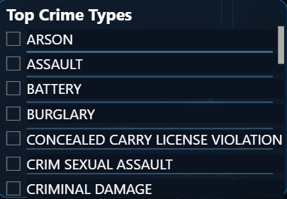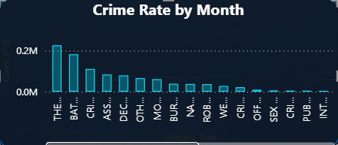

Insight:
It was observed that certain crimes such as theft, battery, and criminal damage occur more frequently compared to others. This indicates that property-related crimes and physical offenses are more prevalent in the dataset.

2. Year-wise Crime Trend
Analyzing crime data over time helps in identifying whether crime rates are increasing, decreasing, or remaining stable.

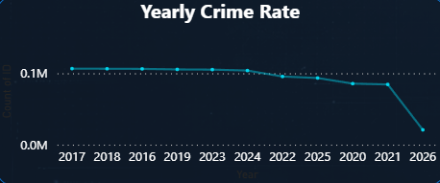

Insight:
The analysis shows fluctuations in crime rates across different years. Certain years exhibit higher crime activity, which may be influenced by socio-economic or environmental factors.

3. Monthly Crime Analysis
Monthly analysis helps identify seasonal patterns in criminal activity.

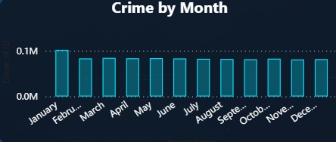

Insight:
Some months show higher crime occurrences, suggesting possible seasonal trends. For instance, crime rates may increase during warmer months due to higher outdoor activity.

4. Crime Distribution by Location
Geographical analysis helps identify crime hotspots.

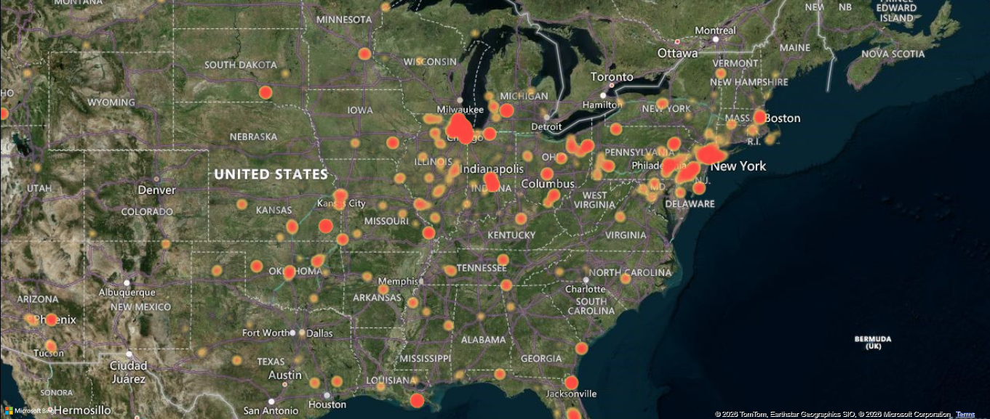

Insight:
Certain areas show higher concentrations of crime, indicating hotspots. These areas may require increased surveillance and resource allocation.

5. Arrest vs Non-Arrest Analysis
Understanding how many crimes lead to arrests provides insight into law enforcement effectiveness.

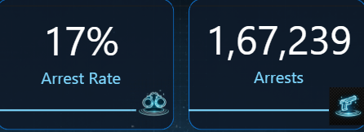
Insight:
A significant portion of crimes do not result in arrests, highlighting potential gaps in enforcement or investigative challenges.

6. Crime Occurrence by Time of Day
Analyzing crime frequency by hour helps identify peak crime times.

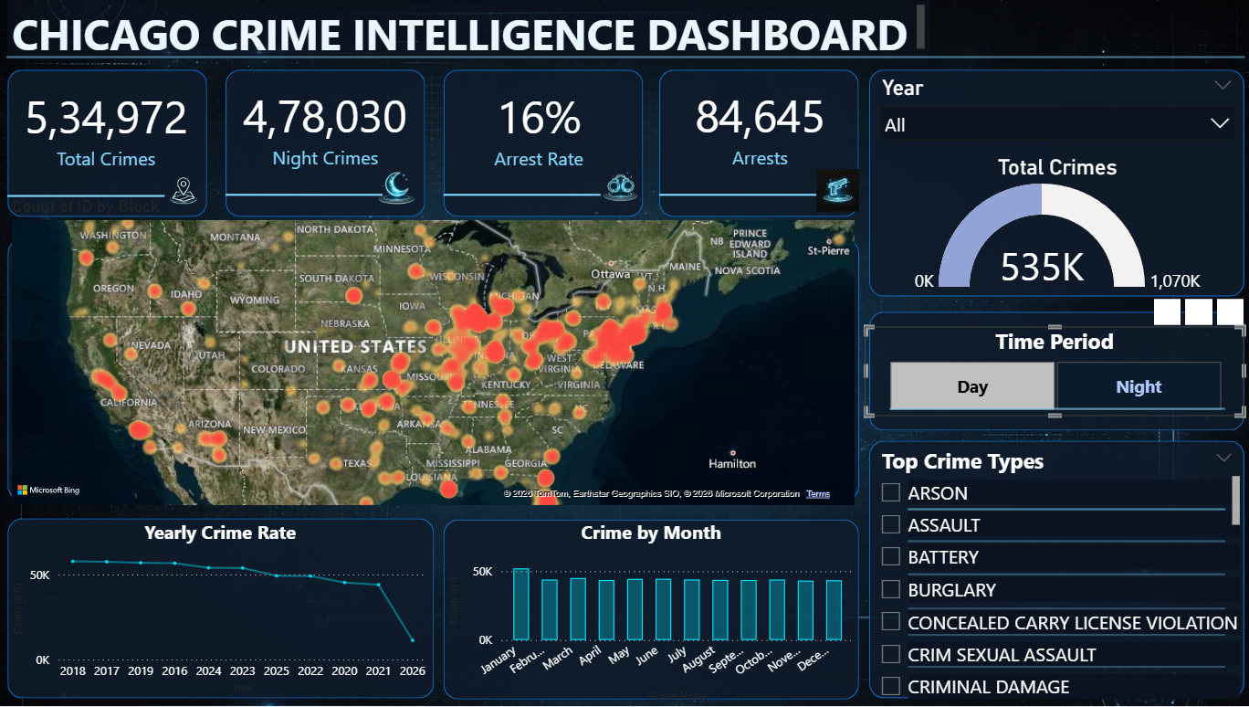

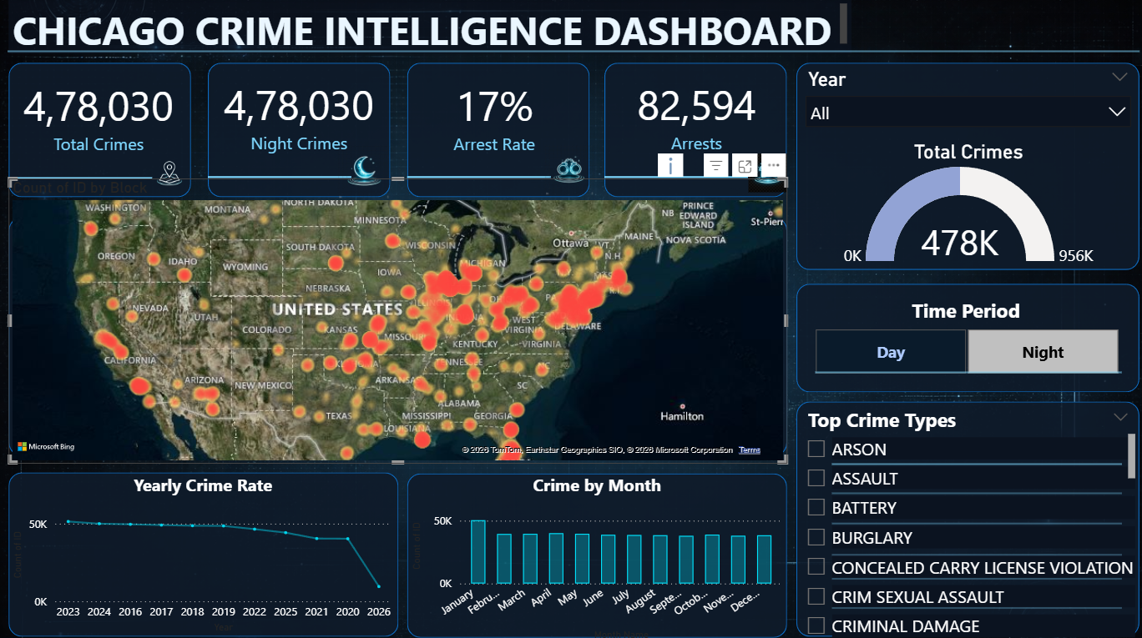

Insight:
Certain hours of the day experience higher crime rates, which can help in planning patrol schedules and preventive measures.

METHODOLOGY

The methodology outlines the systematic approach followed to analyze the crime dataset of Chicago and derive meaningful insights. The project follows a structured data analysis pipeline consisting of data collection, preprocessing, exploratory analysis, and interpretation.

1. Data Collection
The dataset was obtained from publicly available sources, ensuring authenticity and reliability. It contains detailed records of crime incidents, including temporal, spatial, and categorical attributes.

2. Data Preprocessing
Before analysis, the dataset was cleaned and prepared. This included:
- Handling missing values
- Removing irrelevant columns
- Converting date-time fields
- Standardizing categorical variables
This step ensured that the data was consistent and suitable for further analysis.

3. Feature Engineering
Additional features were derived from existing data to enhance analysis. For example:
- Extracting month, day, and hour from the date column
- Grouping similar categories where required
This helped in identifying temporal patterns more effectively.

4. Exploratory Data Analysis (EDA)
EDA was performed using statistical and visualization techniques to:
- Identify trends and patterns
- Detect anomalies
- Understand relationships between variables
Various charts and graphs were used to represent the data visually for better interpretation.

5. Visualization
Data visualization techniques were used to present findings clearly. Graphs such as bar charts, line graphs, and heatmaps helped in highlighting key insights and making the data more understandable.

6. Interpretation of Results
The final step involved analyzing the visualizations and extracting meaningful conclusions. These insights help in understanding crime behavior and identifying potential areas of concern.

TOOLS AND TECHNOLOGIES USED

The following tools and technologies were used to implement this project:

- Microsoft Excel – Used for initial data cleaning, filtering, and basic preprocessing of the dataset.
- Power BI – Used for data visualization, dashboard creation, and analysis of crime patterns through interactive charts and graphs.

IMPLEMENTATION

The implementation of this project was carried out using Excel and Power BI. The dataset was first cleaned and prepared in Excel, where unnecessary columns were removed, missing values were handled, and the data was structured appropriately.

After preprocessing, the dataset was imported into Power BI for further analysis. Various visualizations such as bar charts, line graphs, pie charts, and maps were created to explore patterns in crime data. Power BI’s interactive features allowed for dynamic filtering and deeper insights into trends across time, location, and crime types.

The workflow followed in the implementation can be summarized as:

Data Collection → Data Cleaning (Excel) → Data Import → Visualization (Power BI) → Insights

RESULTS AND FINDINGS

The analysis of the crime dataset from Chicago using Power BI revealed several important patterns and insights related to crime distribution, frequency, and trends.

1. Most Common Types of Crime
The analysis showed that certain types of crimes occur more frequently than others. Crimes such as theft, battery, and criminal damage were among the most reported incidents.
Finding:
This indicates that property-related crimes and physical offenses are the most prevalent, highlighting areas where preventive measures can be focused.

2. Year-wise Crime Trends
The visualization of crime data over the years revealed fluctuations in crime rates, with certain years showing higher crime activity.
Finding:
The variation in crime rates suggests that external factors such as economic conditions, population changes, or policy implementations may influence crime patterns.

3. Monthly and Seasonal Patterns
Monthly analysis indicated that crime occurrences are not evenly distributed throughout the year.
Finding:
Certain months recorded higher crime rates, suggesting seasonal trends. Increased outdoor activity during specific periods may contribute to this variation.

4. Crime Distribution by Location
Geographical analysis highlighted that crimes are concentrated in specific areas of the city.
Finding:
These high-density regions can be identified as crime hotspots, where increased monitoring and law enforcement presence may be required.

5. Arrest Analysis
The comparison between arrest and non-arrest cases revealed that a significant number of crimes do not result in arrests.
Finding:
This may indicate challenges in investigation, lack of evidence, or limitations in enforcement mechanisms.

6. Time-Based Crime Patterns
Analysis of crime occurrence by time of day showed that certain hours experience higher crime activity.
Finding:
Peak crime hours can be identified, which can help in optimizing patrol schedules and preventive strategies.

DISCUSSION

The findings from this analysis provide a deeper understanding of crime behavior in Chicago. The presence of clear patterns across time, location, and crime type highlights the importance of data-driven approaches in crime analysis.

The concentration of crimes in specific areas suggests that targeted interventions can be more effective than generalized strategies. Similarly, identifying peak hours and seasonal trends allows for better allocation of resources and improved planning by law enforcement agencies.

The low arrest rates observed in certain cases point towards potential gaps in investigation or enforcement, which may require further attention. Additionally, the dominance of certain crime types indicates areas where awareness programs and preventive measures can be implemented.

Overall, the use of Power BI enabled interactive exploration of the dataset, making it easier to identify patterns and derive meaningful insights. The visual nature of the analysis enhances understanding and supports better communication of findings.

CONCLUSION

This project focused on analyzing crime data from Chicago using data visualization techniques in Excel and Power BI. Through systematic preprocessing and exploratory data analysis, meaningful patterns and trends were identified across various dimensions such as crime type, time, and location.

The analysis revealed that certain crimes, particularly theft and battery, occur more frequently, indicating the prevalence of property-related and physical offenses. Temporal analysis highlighted fluctuations in crime rates over the years and identified seasonal patterns, while geographical analysis helped in detecting crime hotspots within specific areas of the city.

Additionally, the study provided insights into arrest rates and time-based crime distribution, which can be useful for improving law enforcement strategies and resource allocation. The use of Power BI enabled the creation of interactive dashboards, making the analysis more intuitive and accessible.

Overall, this project demonstrates how data analytics and visualization tools can be effectively used to transform raw crime data into actionable insights, contributing to a better understanding of urban crime behavior.

FUTURE SCOPE

While this project primarily focused on exploratory data analysis and visualization of crime data, there are several opportunities for further enhancement and development. The current analysis provides valuable insights; however, it can be extended to create more advanced and impactful solutions using modern data science techniques.

One major area of improvement is the implementation of predictive modeling techniques. By using machine learning algorithms such as regression models, decision trees, or classification techniques, it would be possible to forecast future crime trends based on historical data. This would allow authorities to anticipate potential crime occurrences and take preventive measures in advance, rather than reacting after incidents take place.

Another potential extension of this project is the integration of advanced machine learning methods for deeper pattern recognition. Techniques such as clustering can be used to group similar crime patterns, while anomaly detection methods can help identify unusual or unexpected criminal activities. These approaches can uncover hidden relationships within the data that are not immediately visible through basic visualization.

The project can also be enhanced by incorporating real-time data analysis. Instead of working with static historical data, integrating live data streams would allow continuous monitoring of crime patterns. This would enable the development of dynamic dashboards that update automatically, providing up-to-date insights for decision-makers.

Additionally, the use of geospatial analysis tools can significantly improve the understanding of crime distribution. By integrating mapping technologies, more detailed and interactive visualizations of crime hotspots can be created. This would help in identifying high-risk zones with greater accuracy and assist in efficient resource allocation by law enforcement agencies.

Further improvements can be made in the area of dashboard development. More advanced and user-friendly dashboards can be designed in Power BI with interactive filters, drill-down capabilities, and customized views. This would allow users to explore the data more effectively and gain deeper insights based on specific criteria such as time period, crime type, or location.

Another important extension is the inclusion of external data sources, such as population density, economic indicators, or weather conditions. Combining crime data with these additional factors can provide a more comprehensive understanding of the causes and influences of criminal activity.

Overall, the future scope of this project lies in transforming it from a descriptive analysis tool into a predictive and decision-support system. By integrating advanced analytics, real-time capabilities, and interactive technologies, the project can evolve into a powerful platform for crime prevention and public safety enhancement.

REFERENCES

[1] City of Chicago, “Crimes – 2001 to Present,” Chicago Data Portal. [Online]. Available: https://data.cityofchicago.org/. [Accessed: Apr. 2026].

[2] Microsoft, “Microsoft Excel Documentation,” Microsoft Support. [Online]. Available: https://support.microsoft.com/excel. [Accessed: Apr. 2026].

[3] Microsoft, “Power BI Documentation,” Microsoft Learn. [Online]. Available: https://learn.microsoft.com/power-bi/. [Accessed: Apr. 2026].

[4] J. Han, M. Kamber, and J. Pei, Data Mining: Concepts and Techniques, 3rd ed. Burlington, MA, USA: Morgan Kaufmann, 2011.

[5] D. Keim, “Information visualization and visual data mining,” IEEE Transactions on Visualization and Computer Graphics, vol. 8, no. 1, pp. 1–8, Jan.–Mar. 2002.

